AAT LAB 1
Name : Swarangi Kothawade
Div Roll no. : A-34

- FACTORIAL

#include<iostream>
using namespace std;

int factorial(int n);
int factorial(int n) {
if(n > 1)
return n * factorial(n - 1);
else
return 1;
}
int main() {
int n;

cout << "Enter a positive integer: ";
cin >> n;
cout << "Factorial of " << n << " = " << factorial(n);

return 0;
}

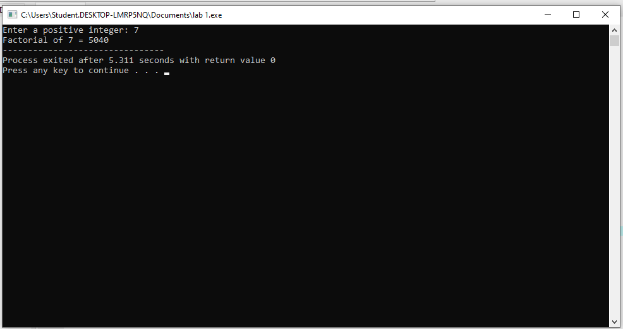

- Tower Of Hanoi

#include <iostream>
using namespace std;

void towerOfHanoi(int n, char s_rod, char d_rod, char a_rod)
{

if (n == 1) {

cout << "Move disk 1 from rod " << s_rod
<< " to rod " << d_rod << endl;
return;
}

towerOfHanoi(n - 1, s_rod, a_rod, d_rod);

cout << "Move disk " << n << " from rod " << s_rod
<< " to rod " << d_rod << endl;

towerOfHanoi(n - 1, a_rod, d_rod, s_rod);
}

int main()
{
int n = 5;

towerOfHanoi(n, 'A', 'C', 'B');

return 0;



